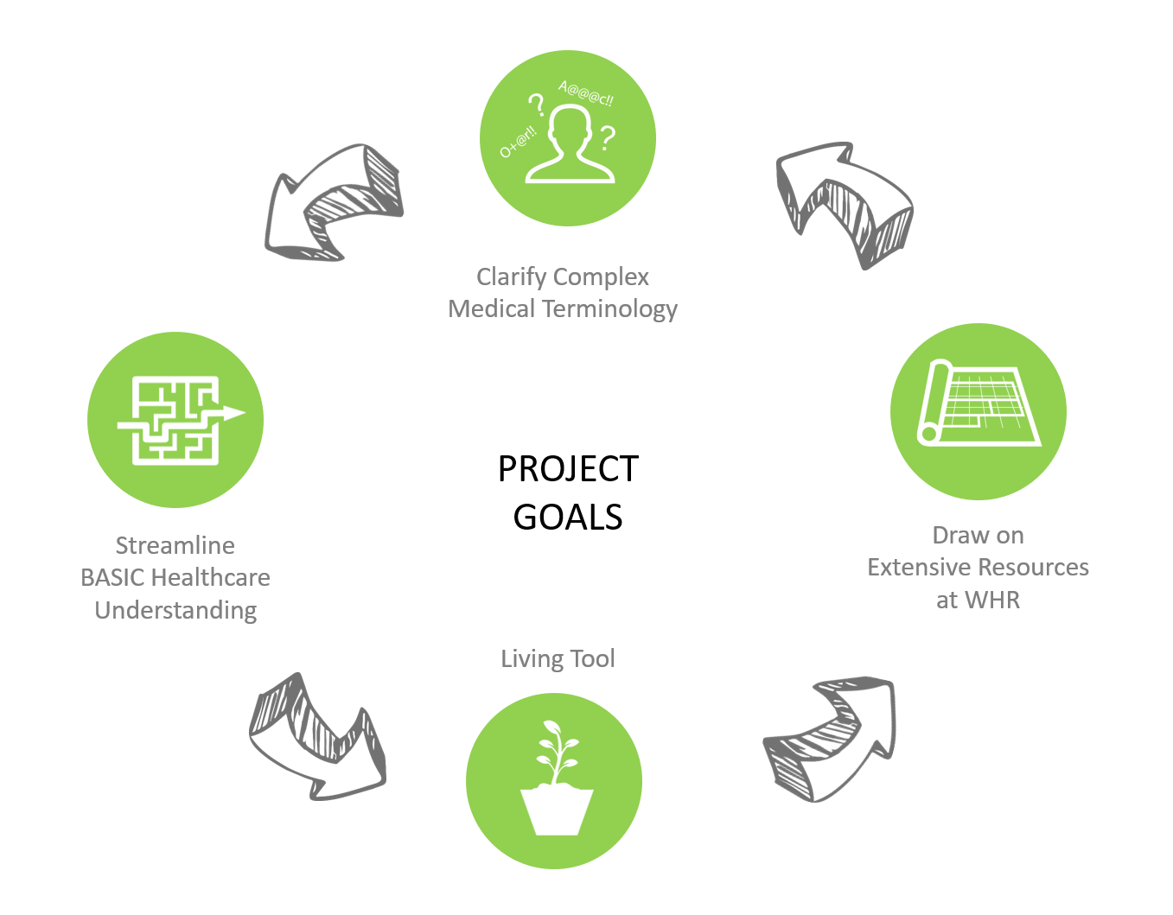

Jessica Welch 2016-2017: Healthcare Terms & Acronyms Database
The purpose of my project is to act as a brief introduction of various terms and concepts important to healthcare design. It attempts to synthesize this knowledge into an easy to use reference tool. The project also covers basic aspects of major hospital departments as an introduction to their design and planning. It is meant to help not only those new to healthcare design but also all of us who find ourselves designing new spaces within the healthcare field.

